**1. head to this link**

<https://docs.cloud.llamaindex.ai/llamaparse/getting_started>

**2. sign up and after that head to the api key section**

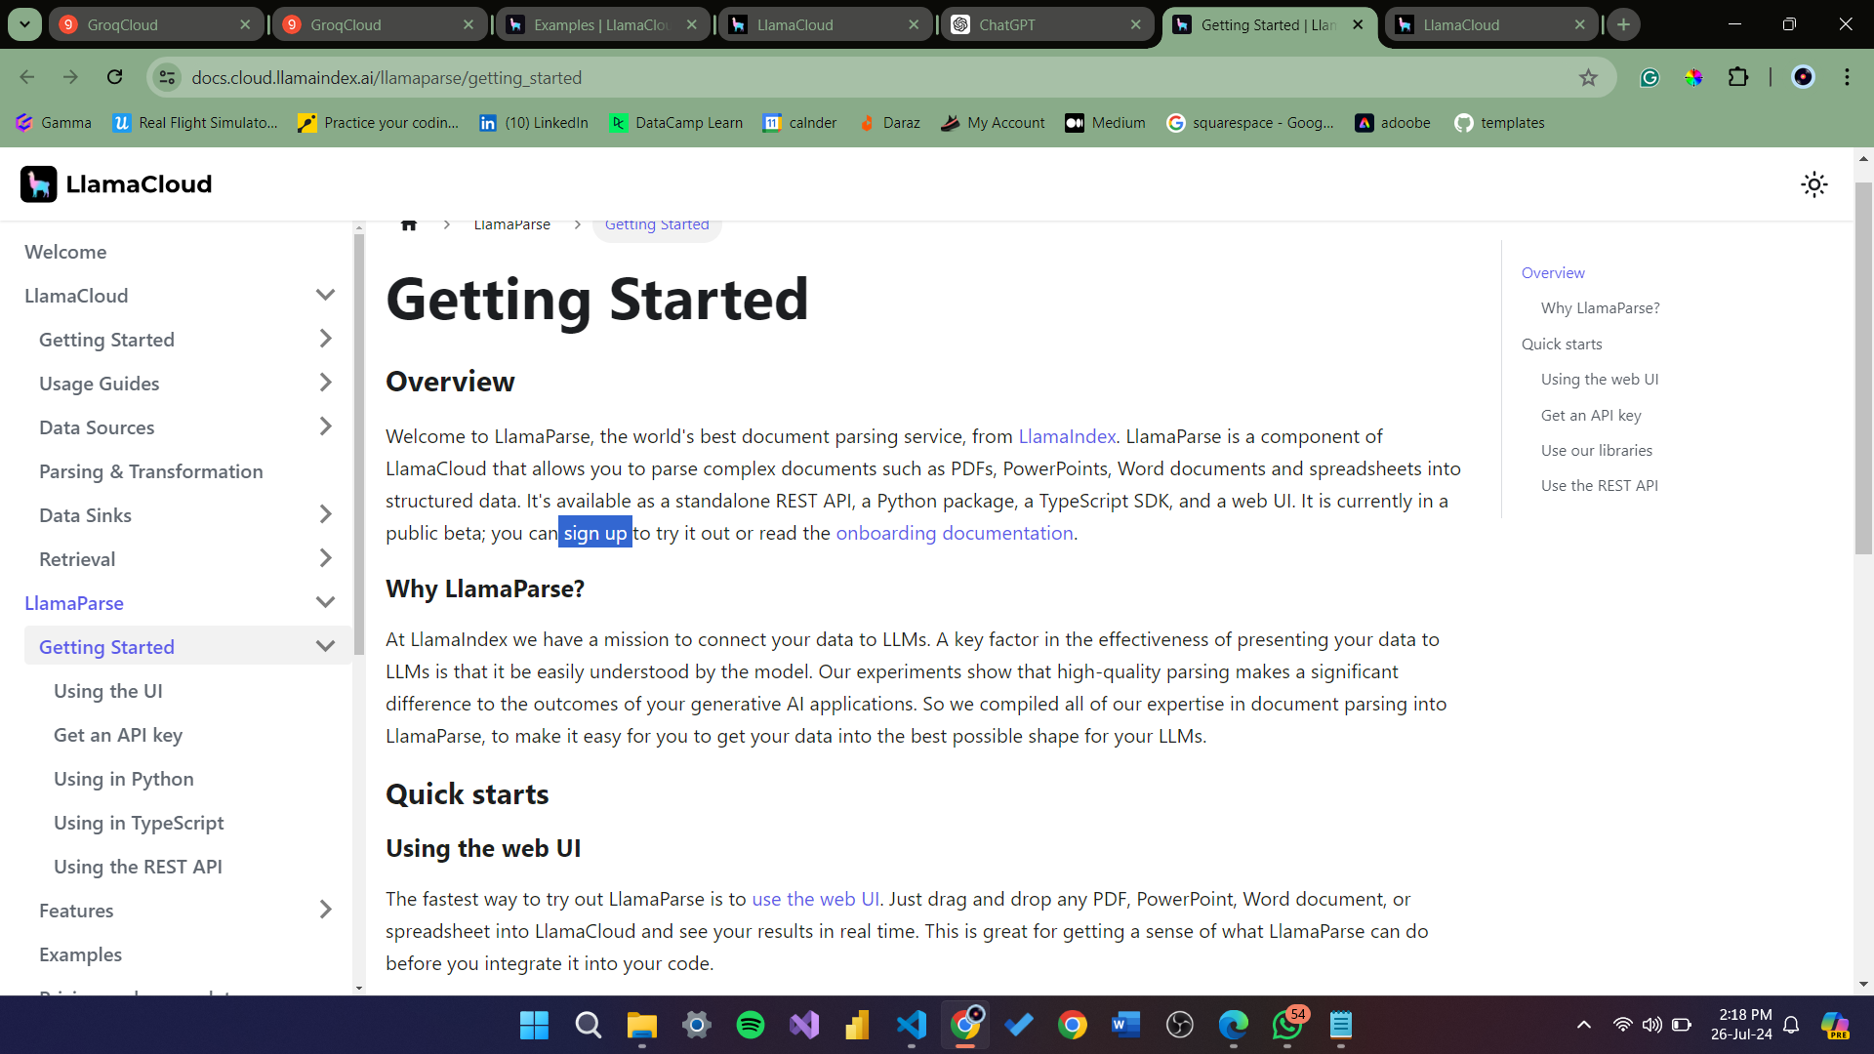

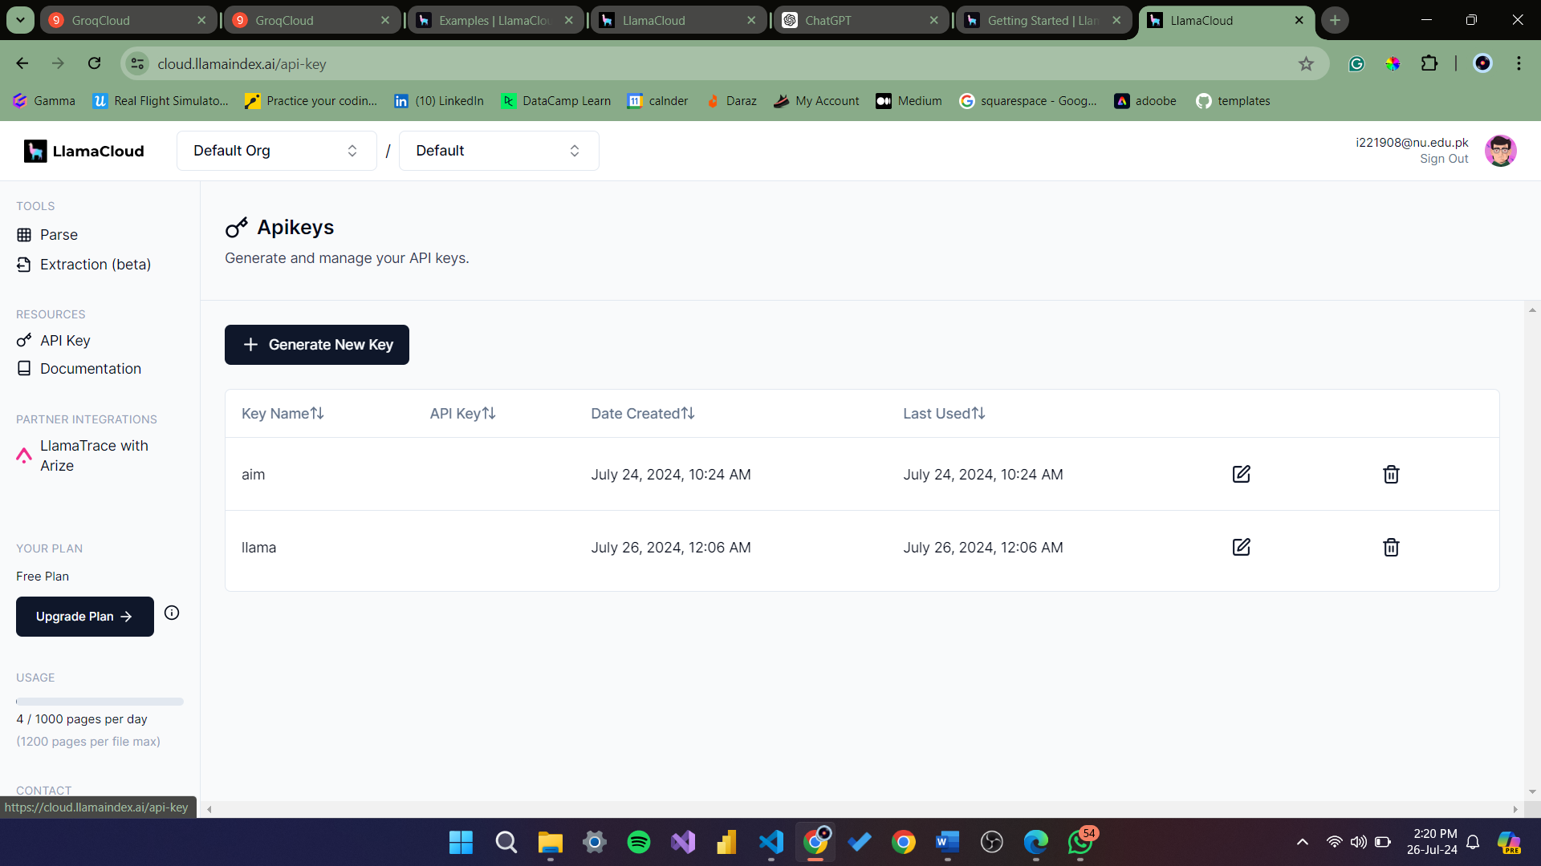

**3. generate an api key**

**4. lets set up the llama environment first ,**  
 I. make an environment file with the name “.env” as it is

ii. LLAMA_CLOUD_API_KEY=llx-xxxxxx   
 paste this in the .env file

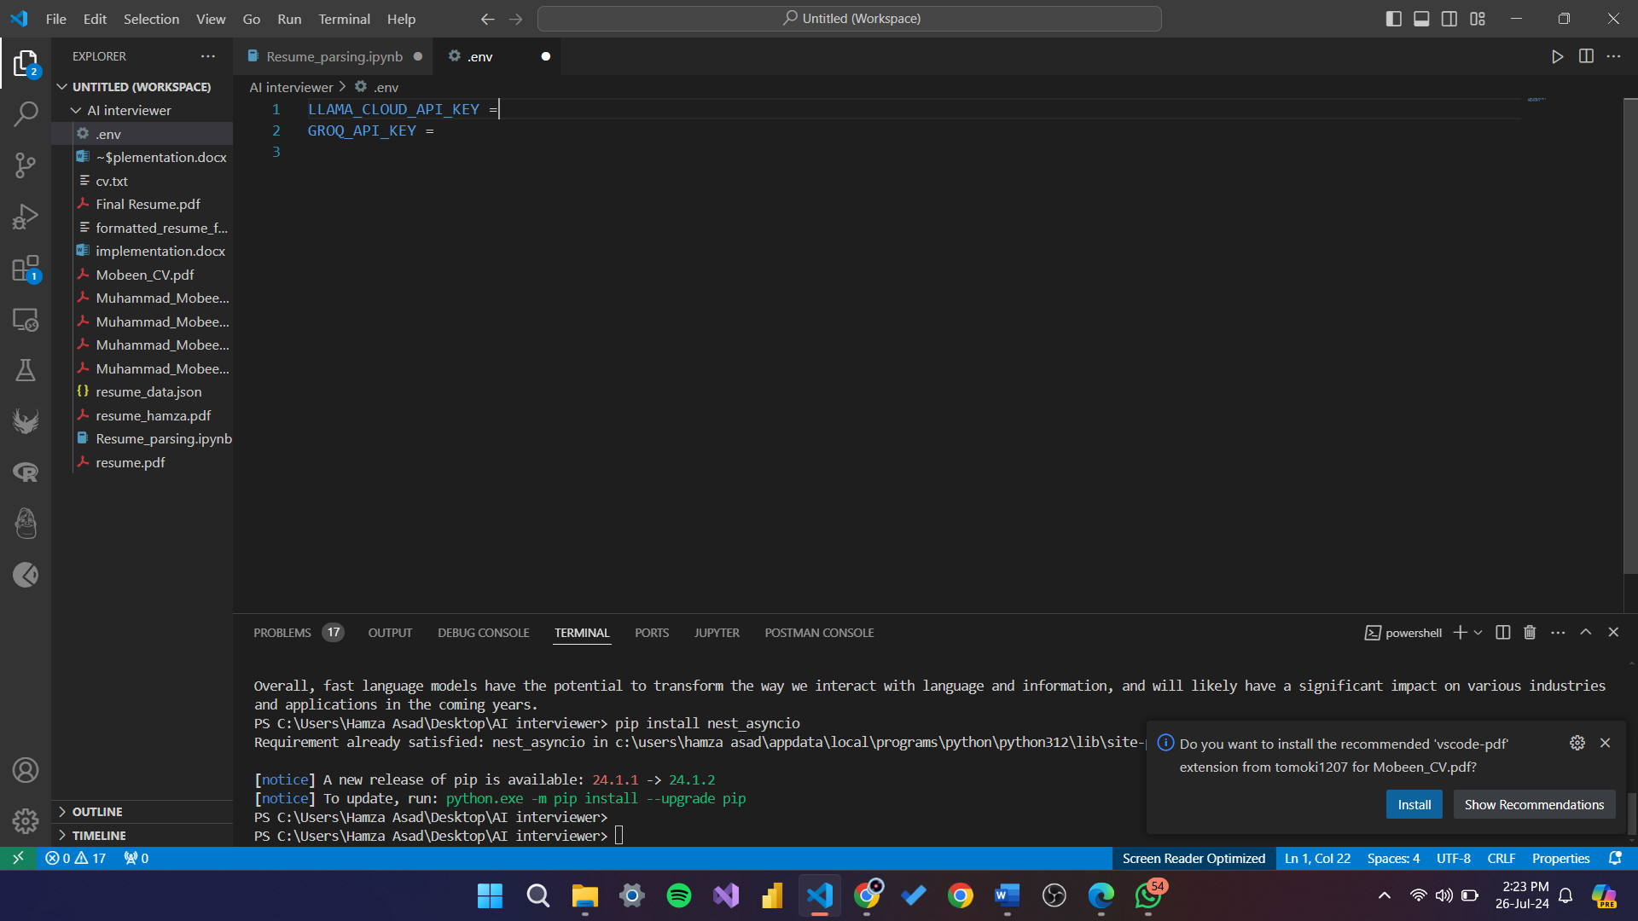

iii. To set up the new py environment, run this in your terminal

pip install llama-index-core llama-parse llama-index-readers-file python-dotenv

**5. Now lets set up the groc env**

[**https://console.groq.com/docs/quickstart**](https://console.groq.com/docs/quickstart)

ii. Generate an API key

iii. In the same env file :

GROQ_API_KEY=your-api-key-here

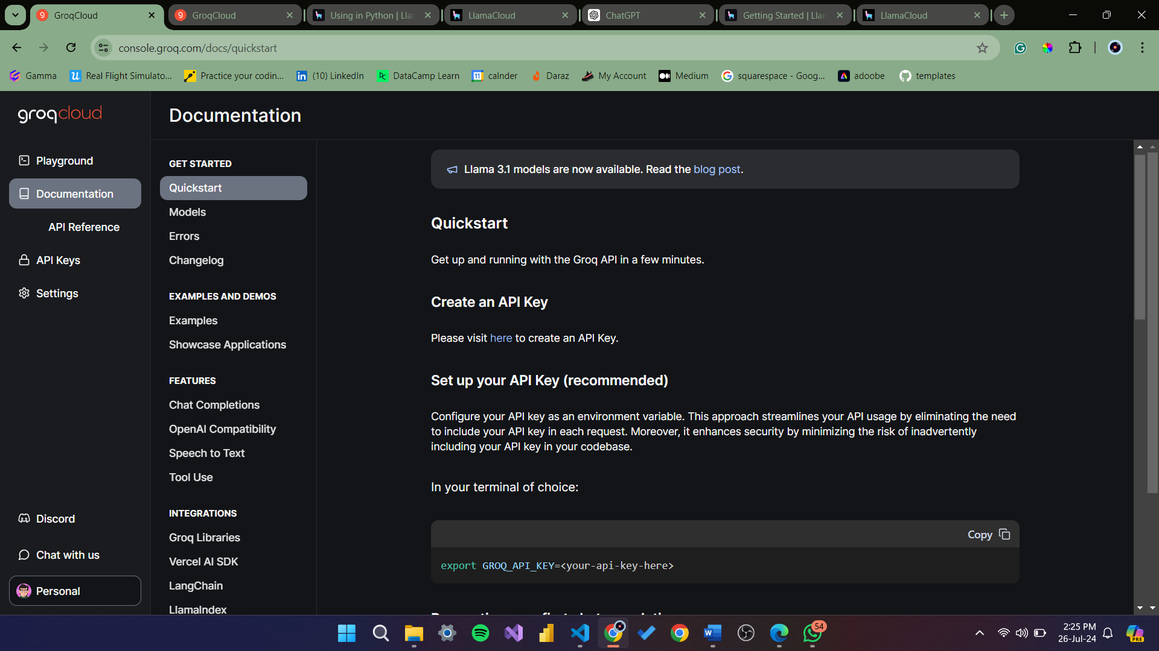

**6. you’re ready to install all dependencies and run the code.**

**- Formats and output the parsed data into “formatted_resume_from_groq.txt”**